CHINMAYA INTERNATIONAL RESIDENTIAL SCHOOL
COIMBATORE

SAMPLE PAPER – 2010

CLASS : VI SUBJECT: MATHEMATICS

- What type of angle is shown in the following figure?
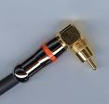

(a) acute angle (b) obtuse angle (c) right angle (d) straight angle

- The LCM of 16, 12, 24 is _____
(a) 24 (b) 6 (c) 96 (d) 48

- The perimeter of the square poster is

38 cm

(a) 1444 sq.cm (b) 152 cm (c) 76 cm (d) 304 cm
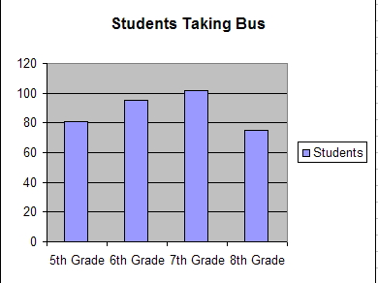
- The bar graph shows the number of students taking bus from grade 5 to grade 8.

Which grade students take the bus maximum?
(a) 5th grade (b) 6th grade (c) 7th grade (d) 8th grade
- Choose the number which is not divisible by 6.

(a) 32886 (b) 9816 (c) 5798 (d) none of these

